**PX4-QUAD-HITL**

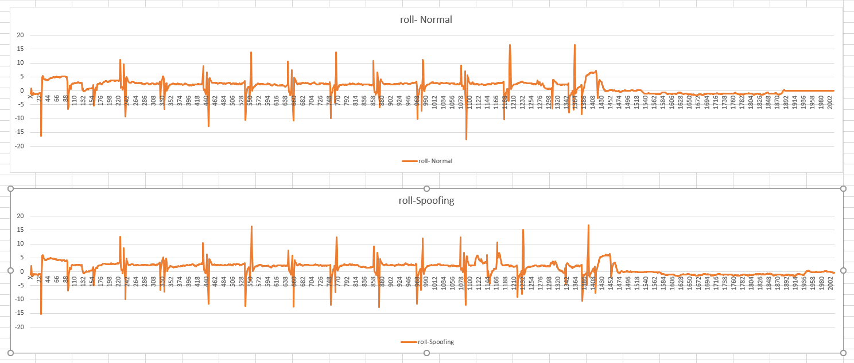

Suspicions point: 1112

**PX4-H480-SITL**

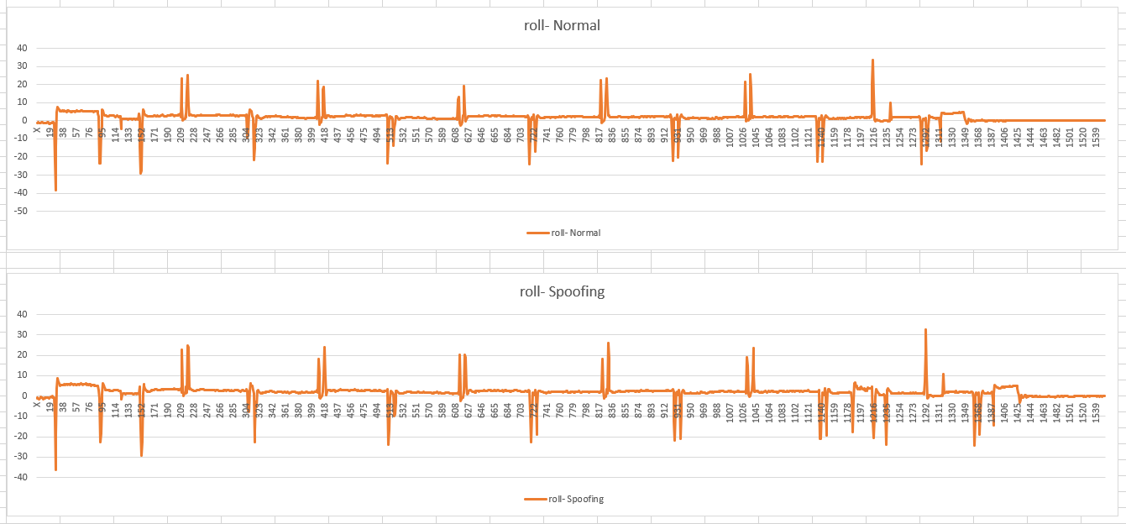

Suspicions point: 1183

**PX4-PLANE-SITL**

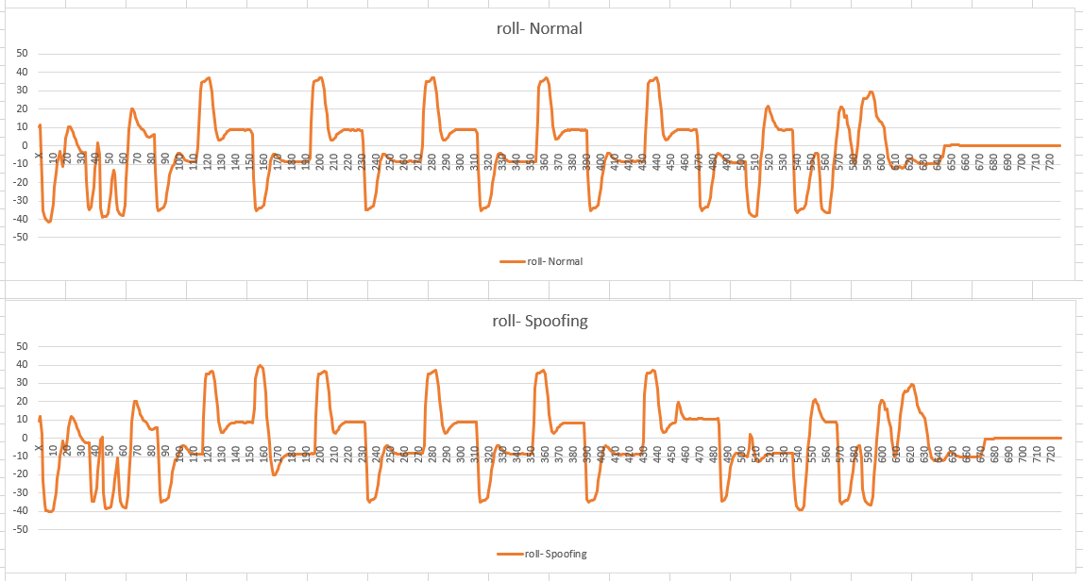

Suspicions point: 152

**PX4-QUAD-SITL**

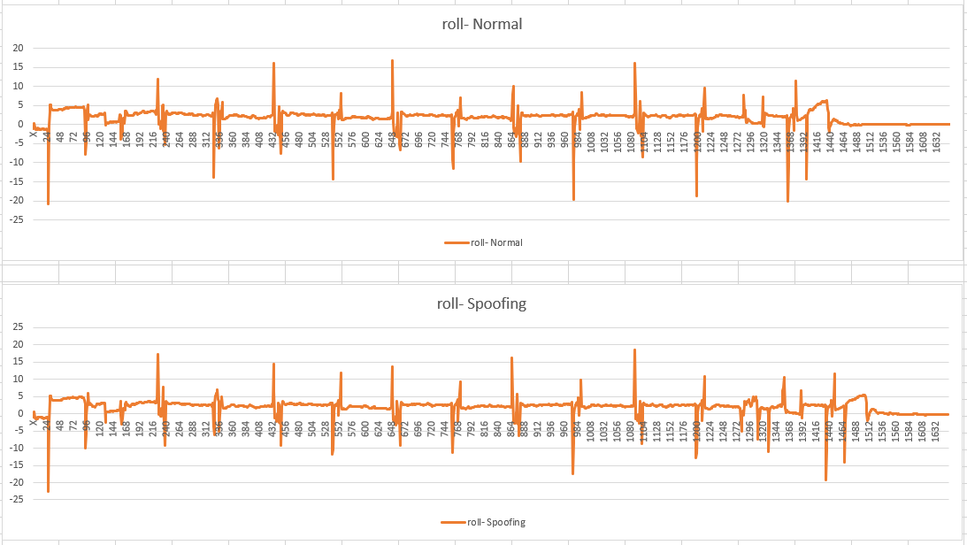

Suspicions point: 1277

**PX4-TAIL-SITL**

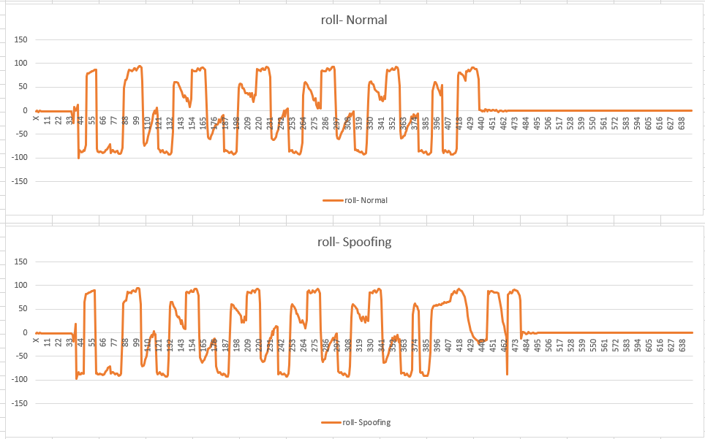

Suspicions point: 407

**PX4-VTOL-SITL**

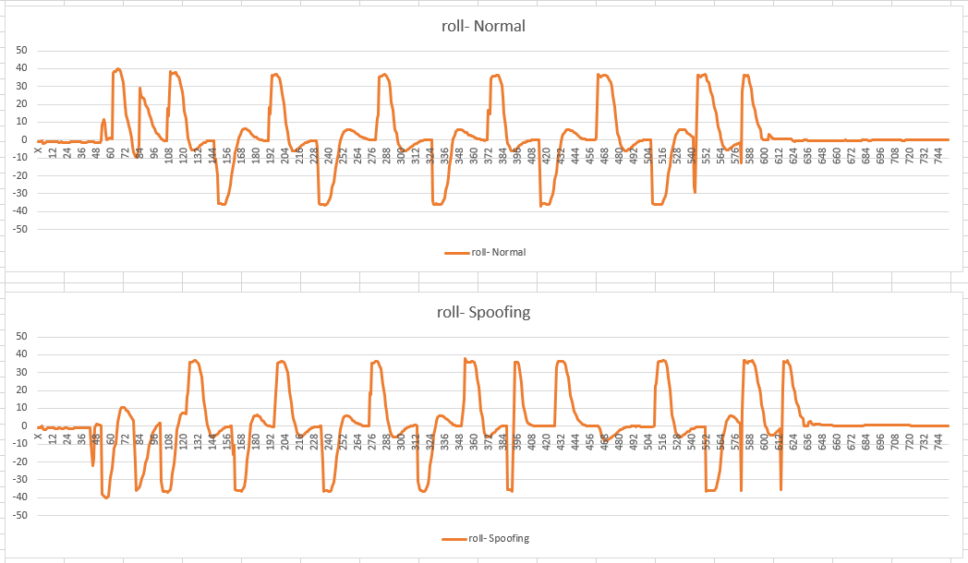

Suspicions point: 43